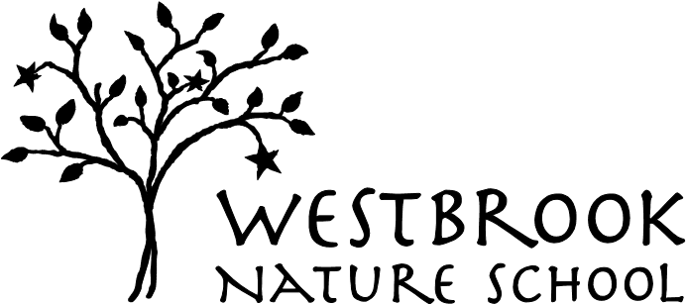
PARENT-CHILD ENROLLMENT FORM

(please print clearly)

Submission Date: _____________________

Fall Winter Spring (circle one) Year ____________

Day Requested (circle one) Tuesday Wednesday Thursday Friday

Child’s Name _______________________________ Date of Birth ___________

Nickname (if applicable) _______________________ Gender _______________

Languages Spoken in the Home __________________________________________

Parent/Guardian Information

First Parent/Guardian:

________________________________________________________________ name

________________________________________________________________ address

________________________________________________________________
home phone cell phone

________________________________________________________________ work phone

________________________________________________________________ email address

________________________________________________________________ occupation

________________________________________________________________ business address (if different)

Second Parent/Guardian:

________________________________________________________________ name

________________________________________________________________ address (if different)

________________________________________________________________
home phone cell phone

________________________________________________________________ work phone

________________________________________________________________ email address

________________________________________________________________ occupation

________________________________________________________________ business address (if different)

Please indicate the names and birthdate of siblings in the home:

________________________________________________________________

________________________________________________________________

How did you hear about Westbrook Nature School?

________________________________________________________________

Please tell us of any allergies or other medical considerations concerning your child:

________________________________________________________________

________________________________________________________________

________________________________________________________________

Do you grant Westbrook permission to use and publish photographs of your child in brochures, flyers, newsletters or websites concerning the School and the publicity of the School.
Yes _______ No ________
_______________________________ ___________________________ parent/guardian signature date

Please note that participation in the Parent-Child Program does not guarantee a place for your child in the Mixed-Age Kindergarten Program.

Westbrook Nature School is non-sectarian and does not discriminate on the basis of gender, race, color, religion, disability, sexual orientation, or national and ethnic origin in its
educational, administrative, admission, athletic, and school programs and policies.

____________________________________________________________
For Internal Office Use Only:

Date Received: ___________
Check # ___________ Amount: __________
Enrollment: Fall Winter Spring Year: ________ Day: Tues Wed Thurs
CC ___

